***Laptop Prices in India***

**SUBMITTED BY – MONIDIPA SAHOO**

**SUBMITTED TO – CHINTAN SIR**

1. Creating schema on MySQL

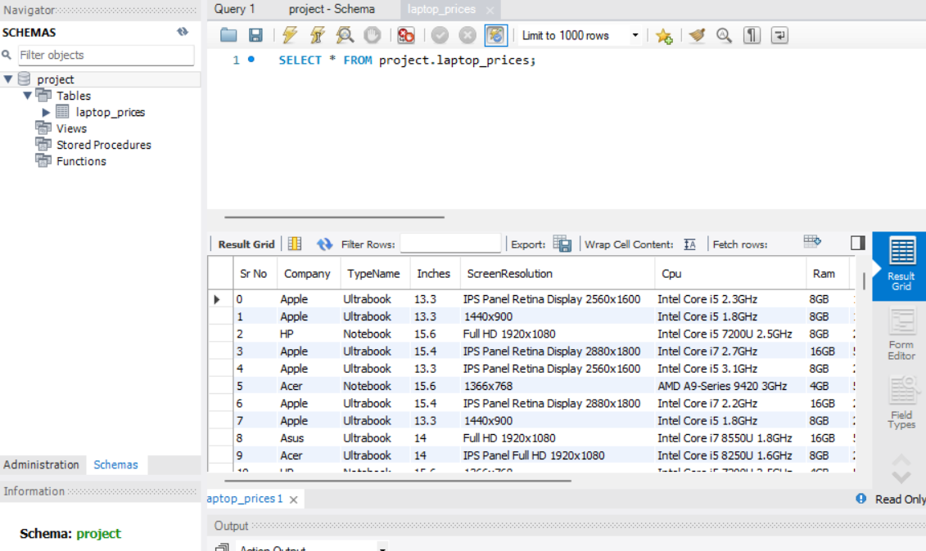

1. Select laptops with a screen size greater than 17 inches:

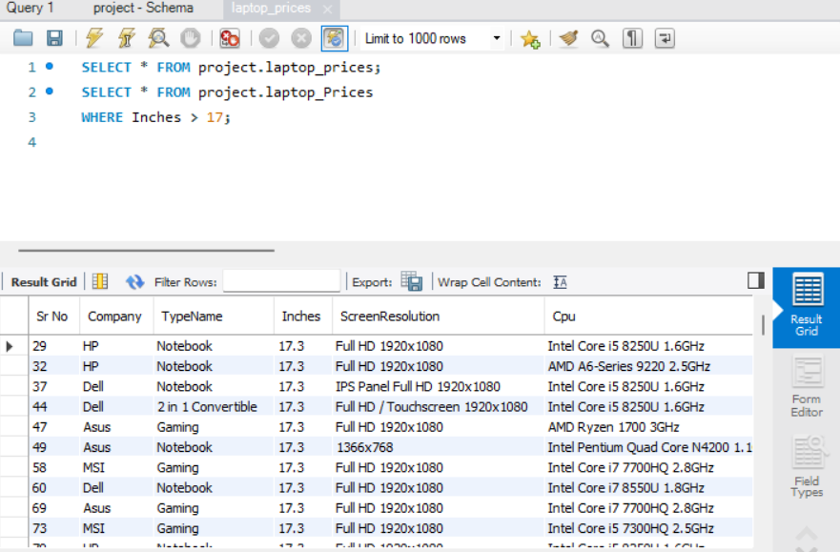

1. Select laptops with a price less than $41025.6:

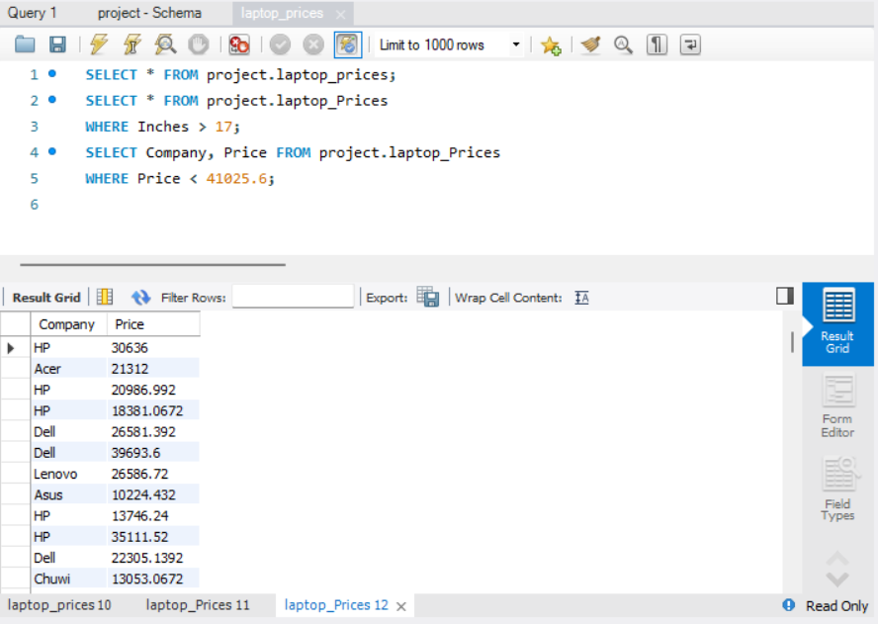

1. Count the number of laptops in the table:

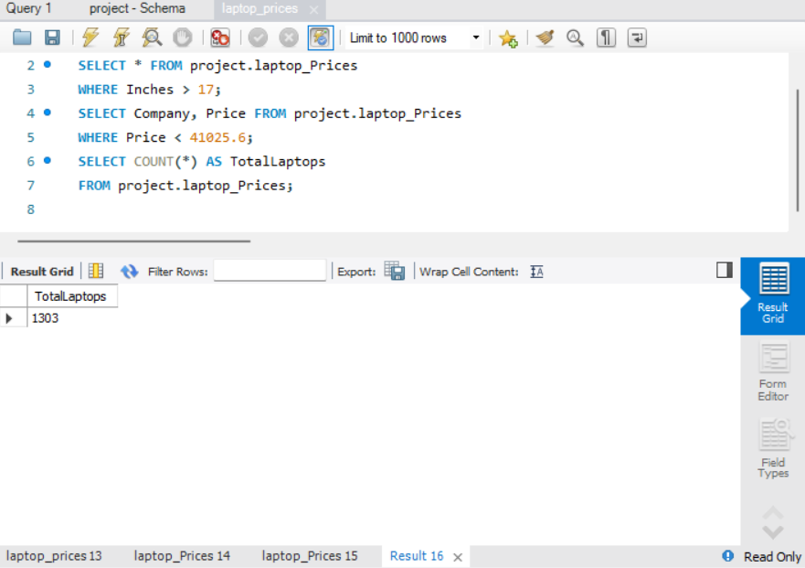

1. Find the average price of all laptops:

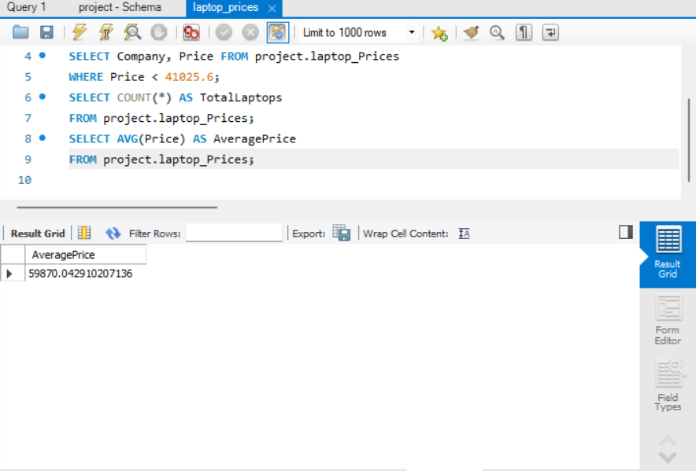

1. Find the laptop with the highest price:

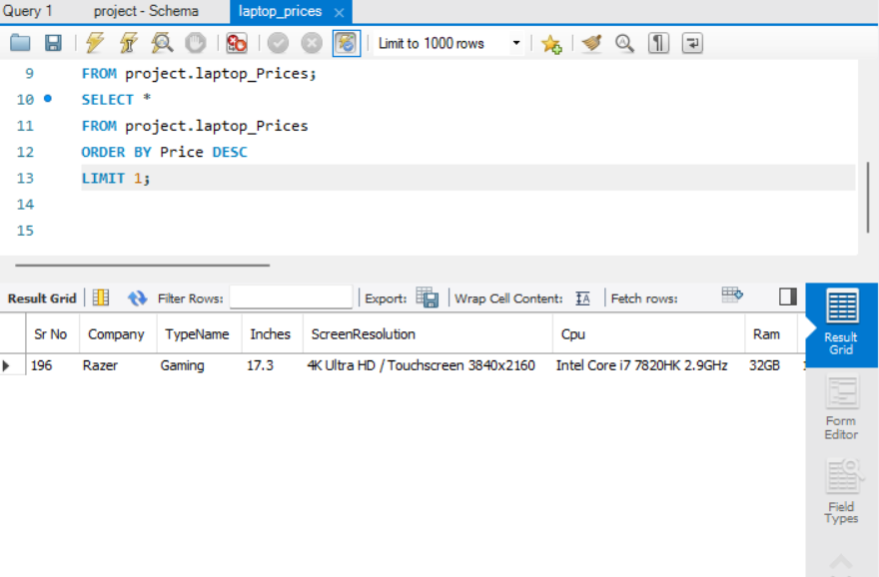

1. Find the laptop with the lowest price:

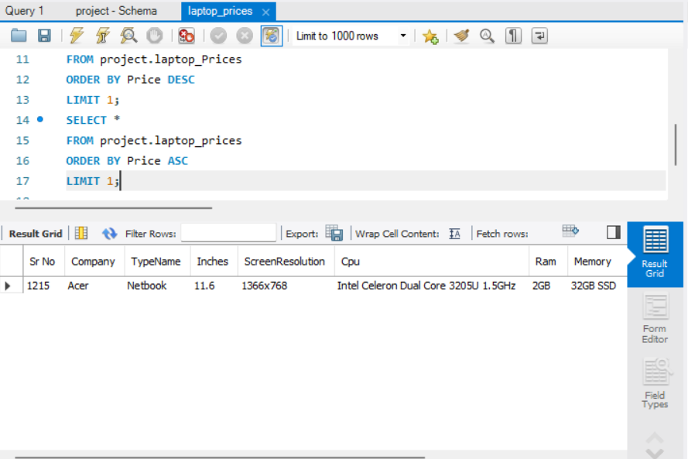

1. Group laptops by Company and calculate the average price for each company:

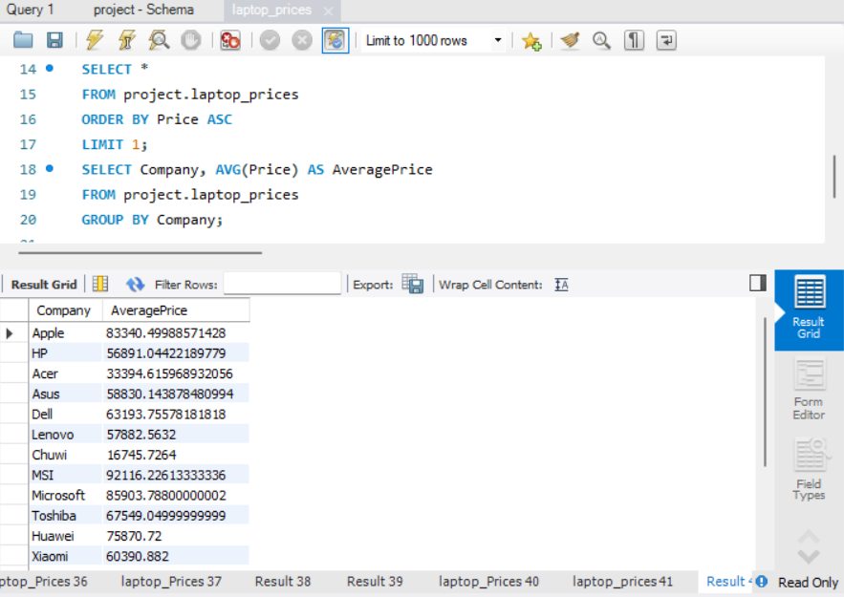

1. Find laptops with a specific CPU type:

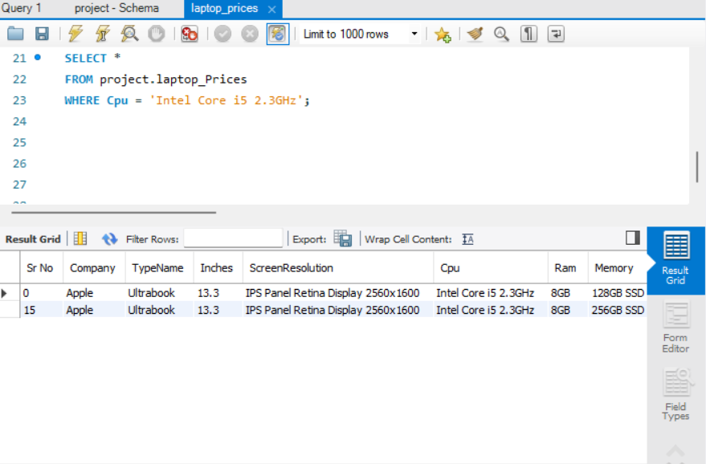

1. Find laptops with a specific GPU:

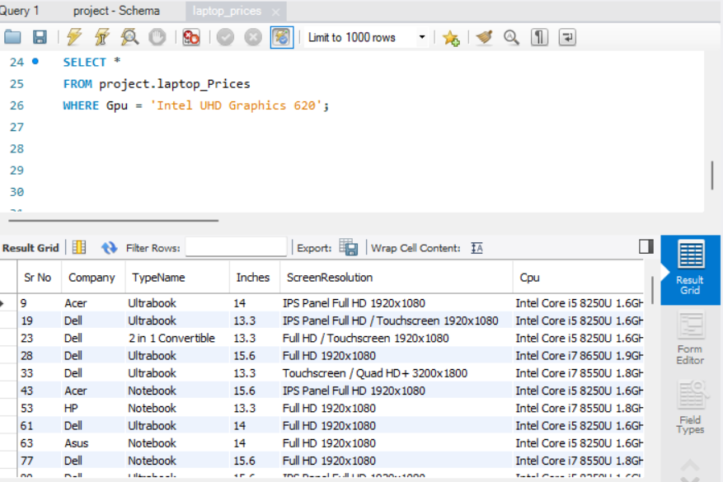

1. Find laptops with a specific operating system (e.g., Windows 10):

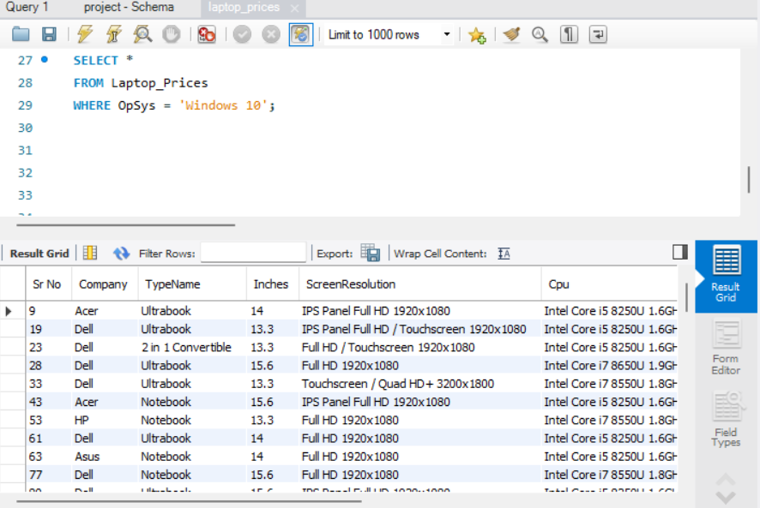

1. Calculate the total RAM available across all laptops:

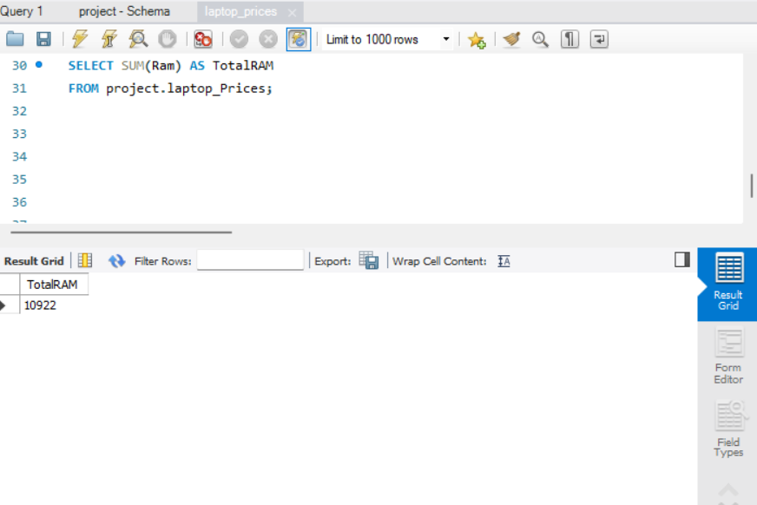

1. Find laptops with a specific screen resolution (e.g., '2560x1440'):

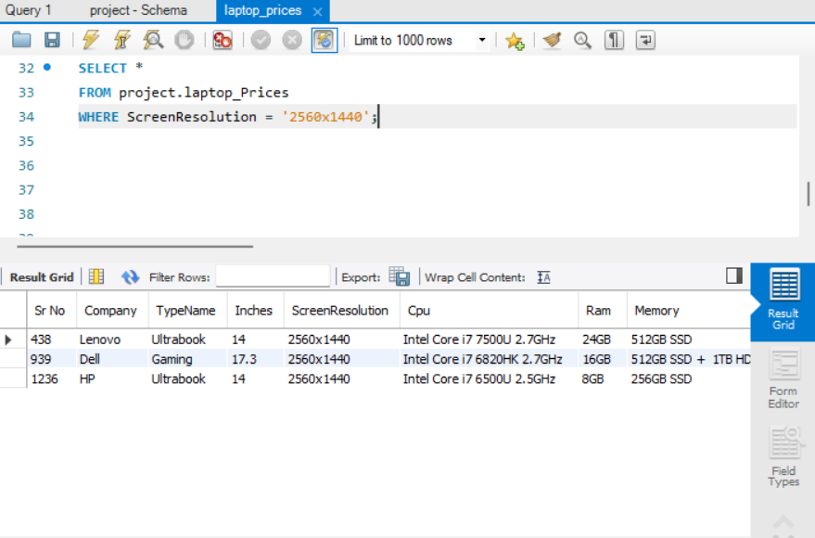

1. Find laptops with a specific memory type (e.g., '1TB HDD'):

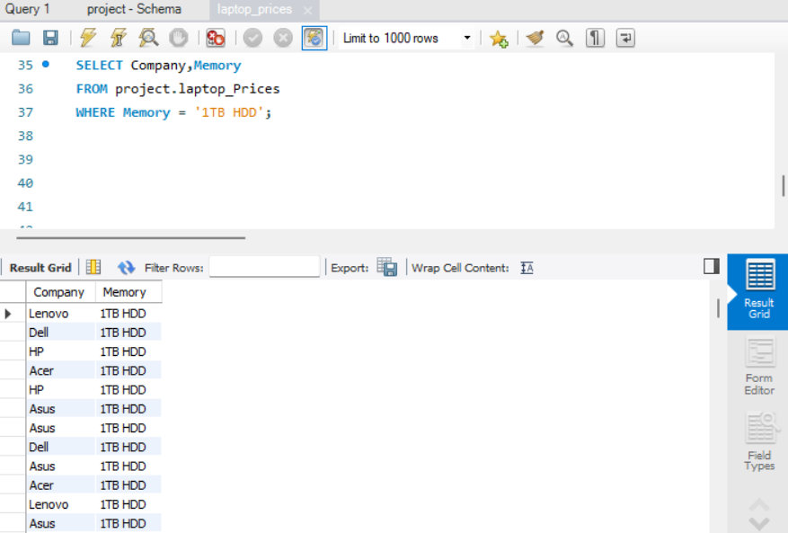

1. Find laptops with a specific company and CPU type:

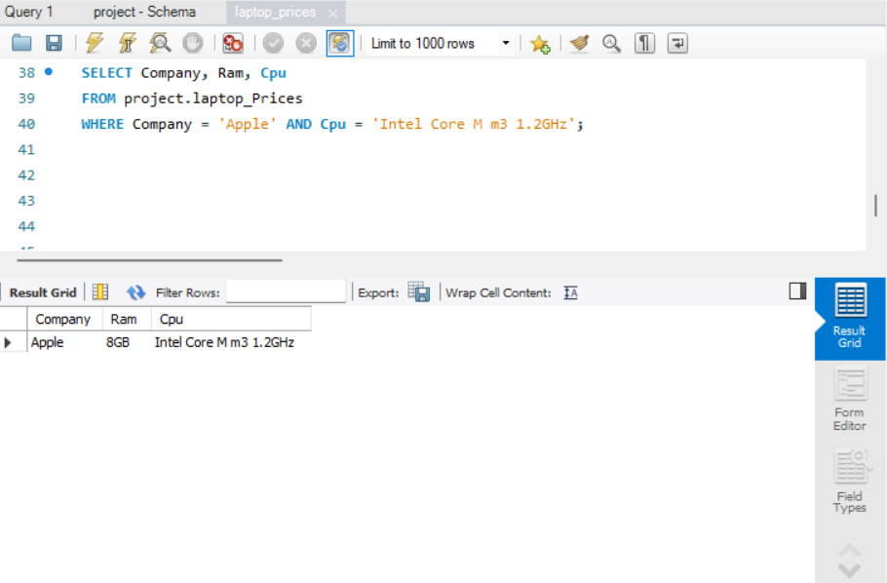

1. Find laptops with a specific company and GPU:

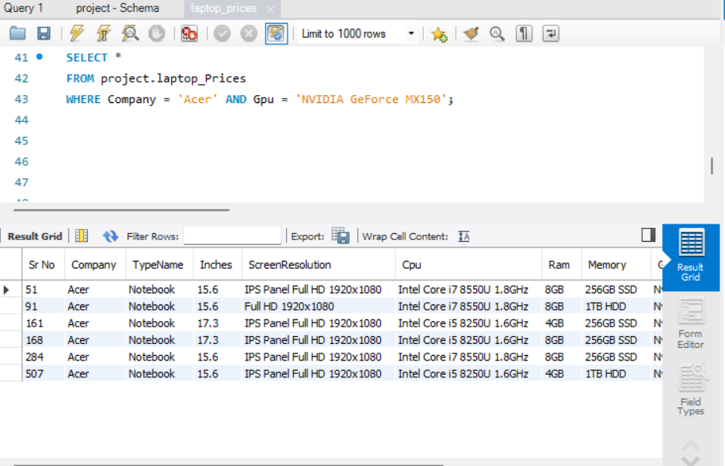

1. Calculate the total weight of all laptops:

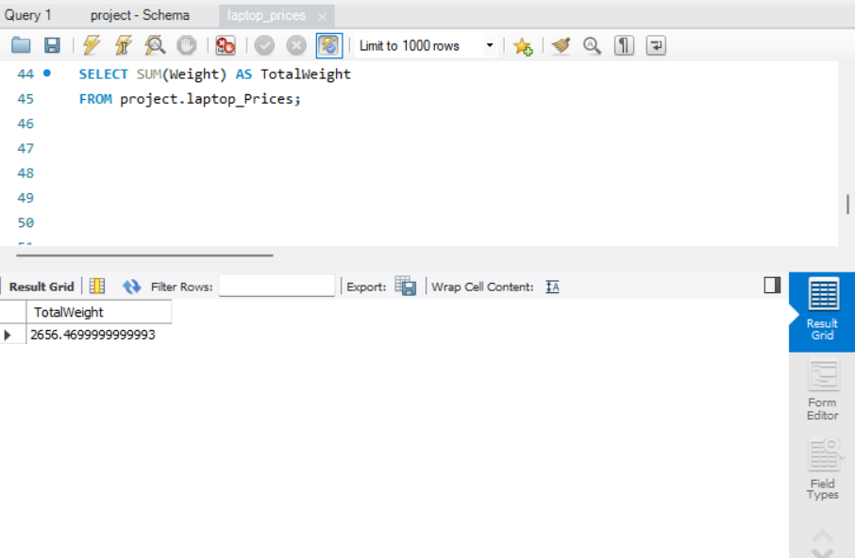

1. Find laptops with a specific screen size and RAM combination:

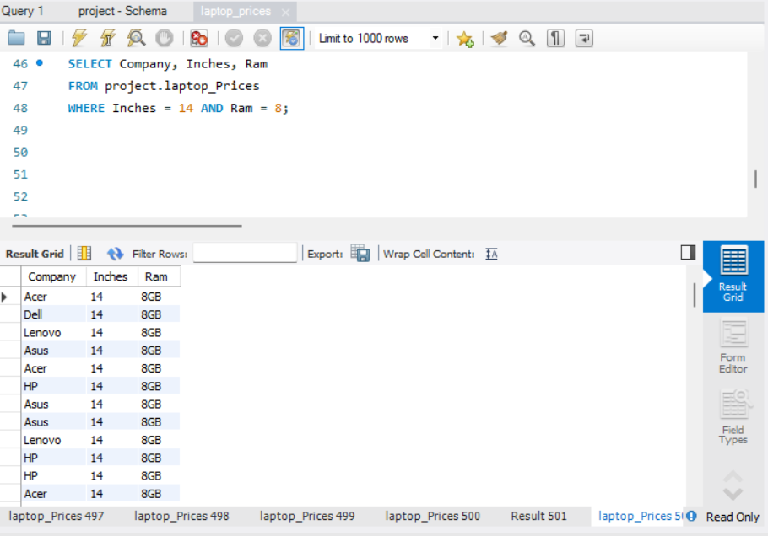

1. Find laptops with a specific company and a price range:

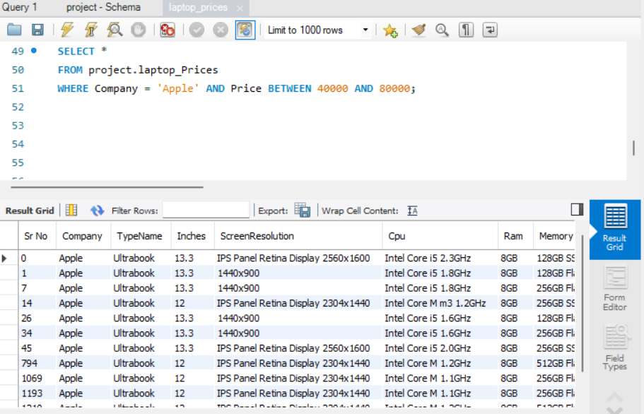

1. Select laptops with a specific operating system and RAM size:

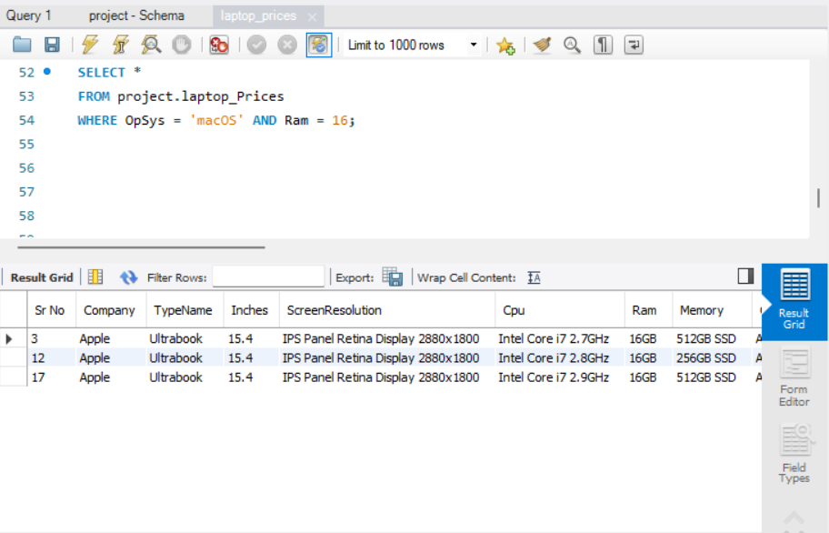

1. Find laptops with a specific company and screen resolution:

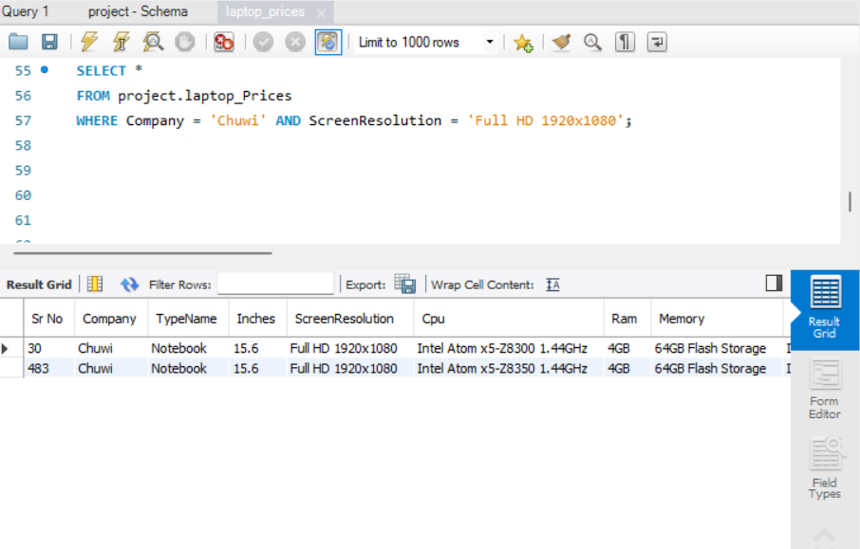

1. Calculate the average screen size of laptops:

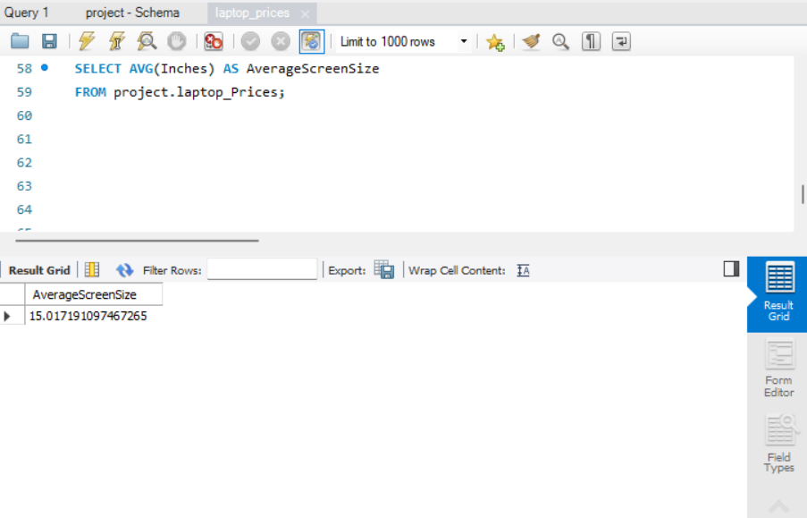

1. Find laptops with a specific company and a GPU with at least Nvidia GeForce 940MX:

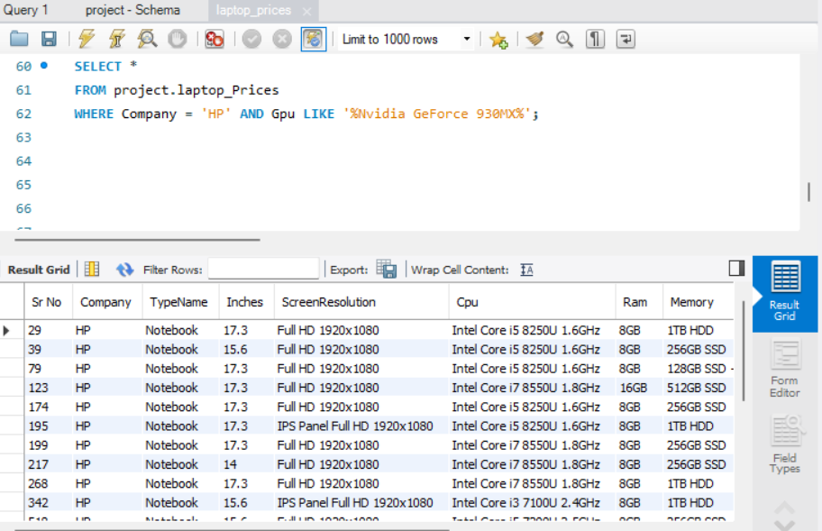

1. Find laptops with a specific company and screen size greater than 15 inches:

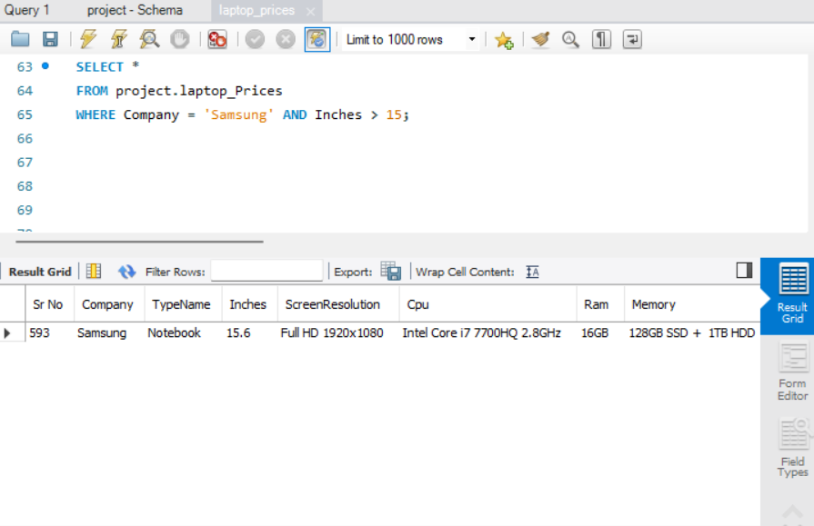

1. Find laptops with a specific company and weight less than 3.5 kg:

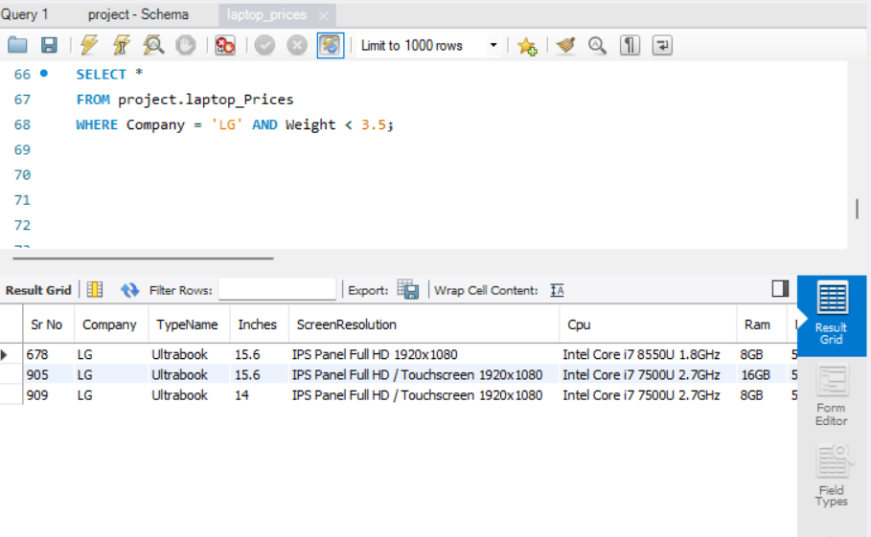

1. Find Total laptop Prices of specific companies:

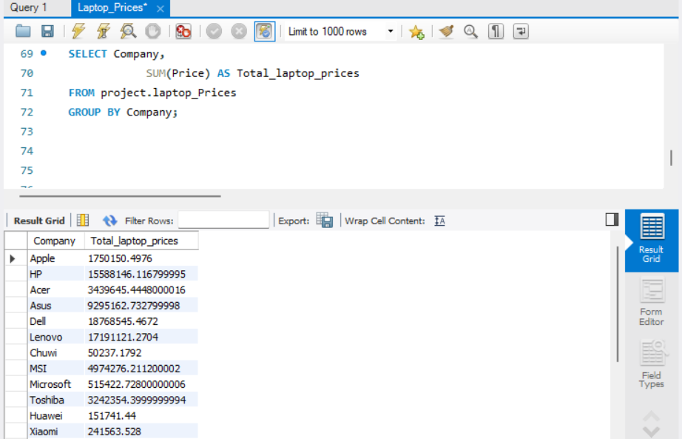

1. Find the Average, Maximum and Minimum prices of Laptop according to Company

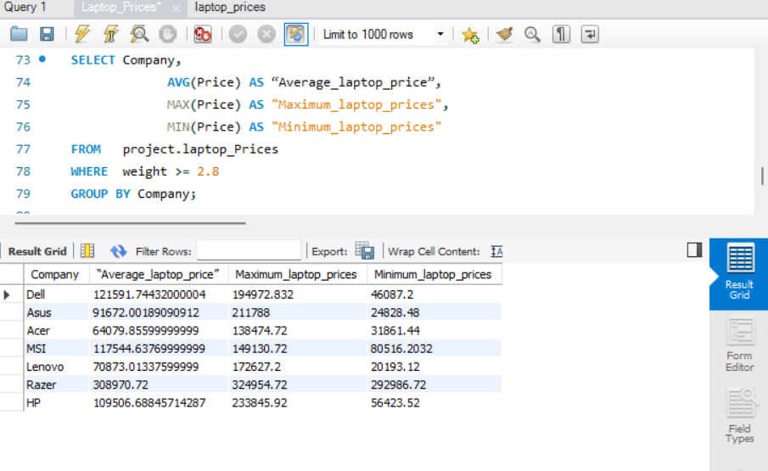

1. Find CPU of all Companies starting with” Intel Core i5”:

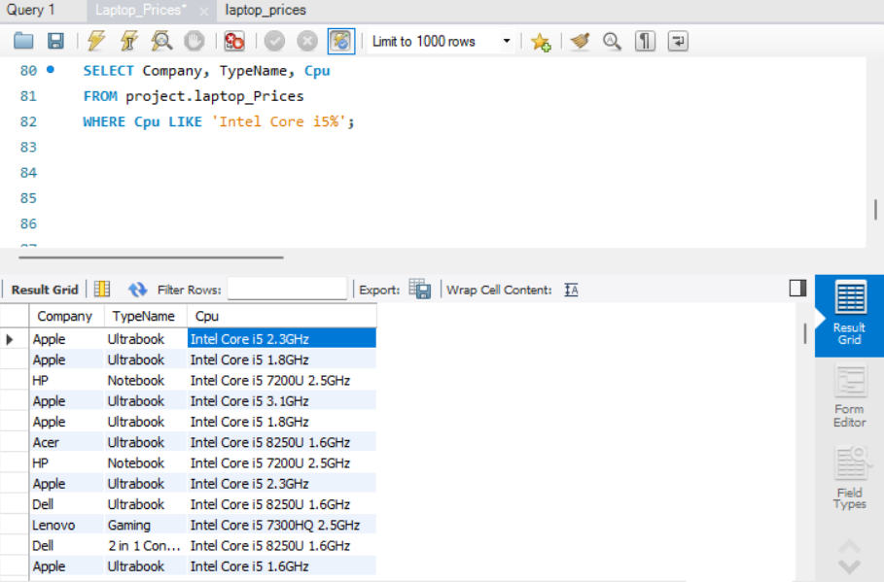

1. Find laptop prices in descending order:

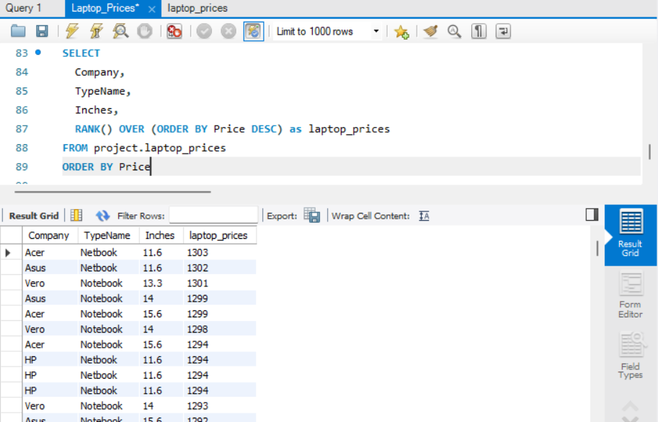

1. Find retrieval of duplicate combination of values in the specified columns:

